**Chapter 4 Exercises**

4.1 Add a PROFINET Remote I/O Subnet to the S7-1500 2

4.1.1 Add a PROFINET IO System. 3

1) Add a PROFINET IO system to the S71500 station. 3

4.2 Add PROFINET Remote I/O Devices 4

4.2.1 Add PROFINET Remote I/O. 5

1) Add an ET 200SP Remote I/O to the PROFINET IO network. 5

4.2.2 Add IO cards to the new station. 6

1) Add IO cards to the new ET200SP station. 6

2) Assign the Profinet Device Name to the online station. 6

3) Define new tags for use in the Program 8

4) Enable control of the pushbutton lamps via the PLC program and the FB Motor Controls block. 8

5) Add a Key Panel to the Project from a Global Library 9

6) Download your changes to the PLC and test. 13

4.3 Add a S7-1200 as a Profinet I-Device 14

4.3.1 Add an S7-1200 to the Project and configure as an I-Device. 15

1) Add an S7-1200 to the project. 15

2) Modify the S7-1500 program to exchange data with the I Device 17

# Add a PROFINET Remote I/O Subnet to the S7-1500

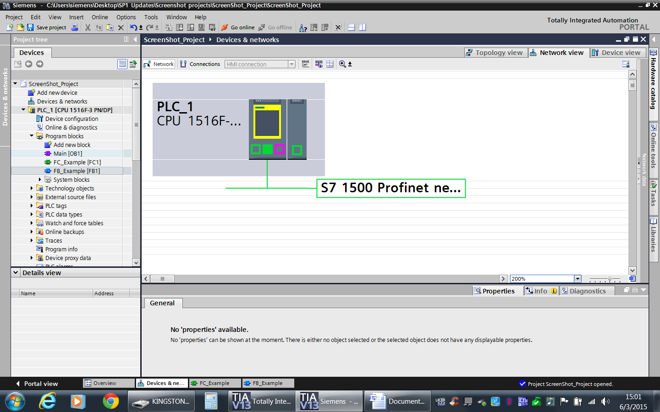

**Description**

PROFINET is the open Industrial Ethernet standard of PROFIBUS International (PNO). PROFINET uses the Industrial Ethernet subnet as the physical medium for data transmission, and takes into account the requirements of industrial automation. For example, PROFINET provides real-time (RT) communication with field devices and isochronous real-time (IRT) properties for motion control. Compatibility with TCP/IP and the IT standards of Industrial Ethernet is retained.

In this exercise, the S7 1500 simulator hardware will be configured for a PROFINET I/O Network.

**Objectives**

Upon completion of this exercise, the student shall be able to:

* Add a PROFINET I/O Subnet

**Prerequisites**

The following prerequisites must be completed before this exercise is started:

* Exercise 3.5 has been completed, OR the Chapter 4 Seed Project Archive has been retrieved and is open for editing

## Add a PROFINET IO System.

|  |
| --- |
| 1. Add a PROFINET IO system to the S71500 station. 2. Open the Devices and networks editor in the Network View. 3. Right mouse click on the right-hand Ethernet port of the S7-1500 CPU and select “Add subnet”. 4. Select the new subnet. In the Inspector window, change the network name to “S7-1500 Profinet Network”.      * Observe: the new subnet and name change appears.   *This concludes Exercise 4.1.* |

# Add PROFINET Remote I/O Devices

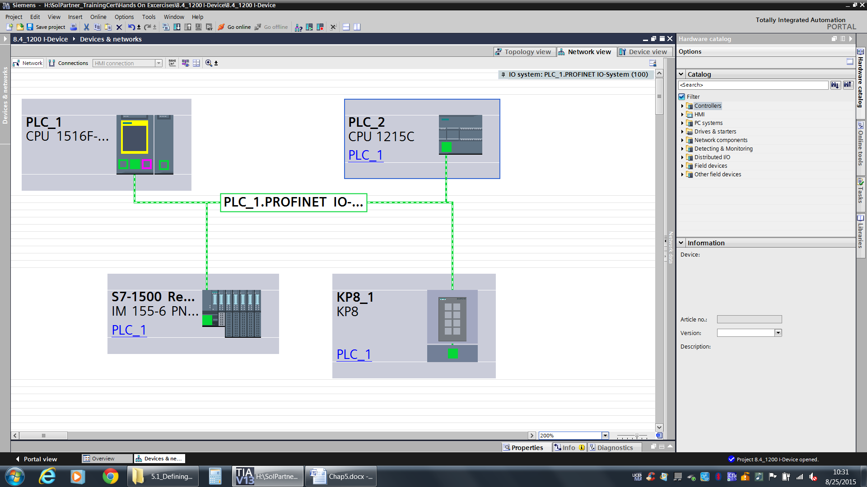

**Description**

You require the following in order to configure a PROFINET IO system: An Industrial Ethernet subnet, an IO controller in a station, and the connection from the IO controller to the Industrial Ethernet subnet.

In this exercise, PROFINET IO devices will be added to the PROFINET IO master network.

**Objectives**

Upon completion of this exercise, the student shall be able to:

* Add and Configure an ET 200SP Remote I/O Device for the PROFINET IO network.

**Prerequisites**

The following prerequisites must be completed before this exercise is started:

* Chapter 4.1 Exercise completed.

## 4.2.1 Add PROFINET Remote I/O.

|  |
| --- |
| 1. Add an ET 200SP Remote I/O to the PROFINET IO network. 2. Return to the network view in the Devices and networks editor in the Network view. 3. From the Hardware task card, drill down to “Distributed IO”, “ET200SP”, “Interface Modules”, “PROFINET”, “IM 155-6 PN ST”. 4. Select the interface module 6ES7 155-6AU00-0BN0 and add it to the S7-1500 Profinet network via drag and drop. 5. Associate the new IM with the S7-1500 Profinet port by clicking of the “Not assigned” hyperlink on the IM and selecting “PLC_1.PROFINET Interface_1” from the list that appears. When associated, note that the network appears as a highlighted dashed line.      1. Set the IP address for the Profinet port on the IM to 192.168.0.3.   Note: Drill down into “PROFINET interface [X1]”, “Ethernet addresses” to set the IP address. |

## Add IO cards to the new station.

|  |
| --- |
| 1. Add IO cards to the new ET200SP station. 2. Open the new remote IO station in the Device view. 3. Begin adding modules to the station to match the actual training hardware:    1. An analog output (AQ) module – 6ES7 135-6HD00-0BA1 FW 1.0 in slot 1.    2. A digital output module – 6ES7 132-6BH00-0BA0 in slot 2.    3. A relay output module 6ES7 132-6HD00-0BB0 –in slot 3.    4. A server module 6ES7 193-6PA00-0AA0 – in Slot 4      1. Assign the Profinet Device Name to the online station. 2. From the Device view of the new ET200SP station, right mouse click on the interface module. 3. From the menu that appears, select “Assign device name”.      1. The Assign PROFINET Device name dialog will appear showing a list of all devices of the same type found on the accessible network. The list includes the device TYPE and NAME. Note the pull-down list of “PROFINET device name” is pre-selected with the IO station.      1. Select the ET200SP device from the list, and then click the “Assign name” button. The dialog will update with the new name when the operation is complete.      1. Close the dialog box by clicking “Close”. 2. Define new tags for use in the Program 3. From the Project tree, select the branch labeled PLC Tags. Add a new tag table and rename it “Remote IO Tags”. 4. Return to the Devices and networks editor. From the Device view, select the ET200SP remote IO station for editing. 5. Select the DQ module in Slot 2. In the Inspector window, access the Properties tab, and then select IO Tags. 6. Add two tags as shown below. Make sure to associate them with the Remote IO Tags tag table.      1. Select the RQ module in Slot 3. This module controls the lights on the top of the demo case. 2. Add IO tags as shown below, making sure to associate them with the Remote IO Tags tag table.      1. Enable control of the pushbutton lamps via the PLC program and the FB Motor Controls block. 2. Open the Main program block [OB1]. 3. In Network 6, add the logic shown below”.      1. Add a Key Panel to the Project from a Global Library 2. Open the Devices and Networks editor in the Network view. 3. From the Task card, access the “Libraries” tab. Click the “Open library” button.      1. From the dialog that appears, browse to the file location specified. Select the “MME Library”. Leave “Open as read only” selected, and click “Open”.      1. Expand the branch labeled “MME Library”, then “Master copies”. Drag and drop the item “KP8 Pre-configured” from the library into the Network view. 2. Associate the KP8 with the PLC. Your configuration should now look like the figure below, but your layout may be different.      1. Access the KP8 Properties in the Inspector Window. Set the KP8 Ethernet address to 192.168.0.4      1. Set the KP8 IO addresses. Set the “Input addresses” “Start Address” to 50. Set the “Output addresses” “Start address” to 50 as well.      1. Right mouse click on the KP8 in the Network view. From the menu that appears, select “Assign device name”. Select the KP8 device in the dialog and click “Assign name”.      1. Return to the Best Practices Library. Drag and drop the item “KP8 Tags” from the library and drop onto the PLC tags folder for the 1500 in the Project tree. This will add all the tags necessary for use with the KP8. 2. Download your changes to the PLC and test. 3. Select PLC_1 from the Project tree and download the hardware and software changes. Your PLC should enter the RUN mode and your ET200SP station should have all green lights on all devices. If not, STOP and notify your instructor. 4. Create a new Watch Table named “KP8 Testing”. Copy all of the tags from the KP8 Tags tag table and paste them into the new watch table. 5. Activate “Monitor” in the watch table. Exercise the inputs and test the outputs to see how the KP8 works. 6. Add the tags “1500 Demo Case Top Lights – Green”, “1500 Demo Case Top Lights – Red”, and “1500 Demo Case Top Lights – Blue” to the KP8 Testing watch table. 7. Test the top lights by changing the values in the watch table. 8. From the Project tree, select the PLC_1 S7 1500 object. 9. End all testing and go offline by selecting the offline button at the top of the screen. 10. Save your project.   *This concludes Exercise 4.2.* |

# 4.3 Add a S7-1200 as a Profinet I-Device



**Description**

PROFINET supports the cyclic data exchange between two PLCs using the “I-Device” function. This requires a PLC to have its Profinet configuration defined as an I-Device.

This exercise will have the student add an S7-1200, configure it as an IO device, associate it with the S7-1500, and exchange data.

**Objectives**

Upon completion of this exercise, the student shall be able to:

* Add and configure an S7-1200 as an I-Device.

**Prerequisites**

The following prerequisites must be met before this exercise is started:

* Exercise 4.2 has been completed.

## Add an S7-1200 to the Project and configure as an I-Device.

|  |
| --- |
| 1. Add an S7-1200 to the project. 2. From the Project tree, double click on “Add new device”. In the dialog that appears, select “PLC”, then “S7-1200”, then “CPU”, then “CPU 1215C AC/DC/Rly”, then “6ES7 215-1BG40-0XB0”. Verify the PLC version is version 4.1. Accept the default name of “PLC_2”, leave “Open device view” checked, and click “OK”.      1. Access the properties of the newly added PLC_2. Under “PROFINET interface”, set the IP address to 192.168.0.6. 2. Assign the new device to the S7-1500 Profinet Network subnet. 3. Enable the clock byte and system memory byte. 4. Under “Operating mode”, check the “IO device” option. Using the pull-down, associate the 1200 with the “PLC_1.PROFINET interface_1”.      1. Under “I device communications”, configure a transfer area of one byte in each direction between the PLCs. Use Input byte 100 and Output byte 100 for both areas. Note: Click the arrow to transfer in the other direction for Transfer area_2.      1. Open the Default Tag Table for the S7-1200 just added. Add the following tags:   Inputs from Transfer Area (BYTE) IB100  Outputs to Transfer Area (BYTE) QB100  Clock Byte Data from 1500 (BYTE) MB100   1. In PLC_2, open the Main program block [OB1]. Enter the following program code to move data from the clock byte to the transfer area, and to move received data from the 1500 via the transfer area to a memory location. Note: The “Move” instruction can be found in the instructions task card under Basic Instructions, Move operations.      1. Download the changes to the S7-1200 PLC. Note the PLC is in the default state, so the “Extended download to device” will need to be used. 2. Make sure you select “Start all” to start the S7-1200 after the download. 3. Note that when the 1200 resumes the Run mode it will indicate an error as the IO controller hasn’t been configured yet. 4. Modify the S7-1500 program to exchange data with the I Device 5. Open the Default tag table and add the following tags to the PLC default tag table:   Inputs from Transfer Area (BYTE) IB100  Outputs to Transfer Area (BYTE) QB100  Clock Byte Data from 1200 (BYTE) MB100   1. Add the following code to a new network in the Main [OB1] program in the S7-1500.      1. Download the changes to the S7-1500. MAKE SURE to download both the software AND the hardware. 2. Monitor the Main program in both PLCs to see the data being read and written. 3. Save your project.     *This concludes the Chapter 4 exercises.* |